**EXPERIMENT 3**

**Aim:** To create an .arff file.

**Theory:**

Attribute Relation File Format (ARFF), this has two parts:

1. The header section defines the relation (data set) name, attribute name and the type.
2. The data section lists the data instances.

An ARFF file requires the declaration of the relation, attribute and data.

* @relation: This is the first line in any ARFF file, written in the header section, followed by the relation/data set name. The relation name must be a string and if it contains spaces, then it should be enclosed between quotes.
* @attribute: These are declared with their names and the type or range in the header section.

Weka supports the following data types for attributes:

* Numeric
* <nominal-specification>
* String
* date
* @data – Defined in the Data section followed by the list of all data segments

**Procedure:**

To create an .arff file the steps involved are:

1. Open Notepad or any text editor.
2. Make a relation Employee.
3. Give attributes to it like name, age, gender
4. Give values to the attributes.
5. After everything is done save the file as “filename.arff”,Click OK.
6. Open WEKA and load the .arff file created.
7. Go to classify and click on cross-validation radio button
8. The value of Folds should be equal to your instances & Press Start.
9. Perform same action in all tabs.

**Code:**

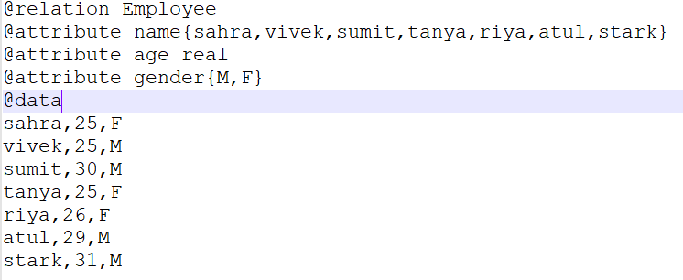

**Classifier Output:**

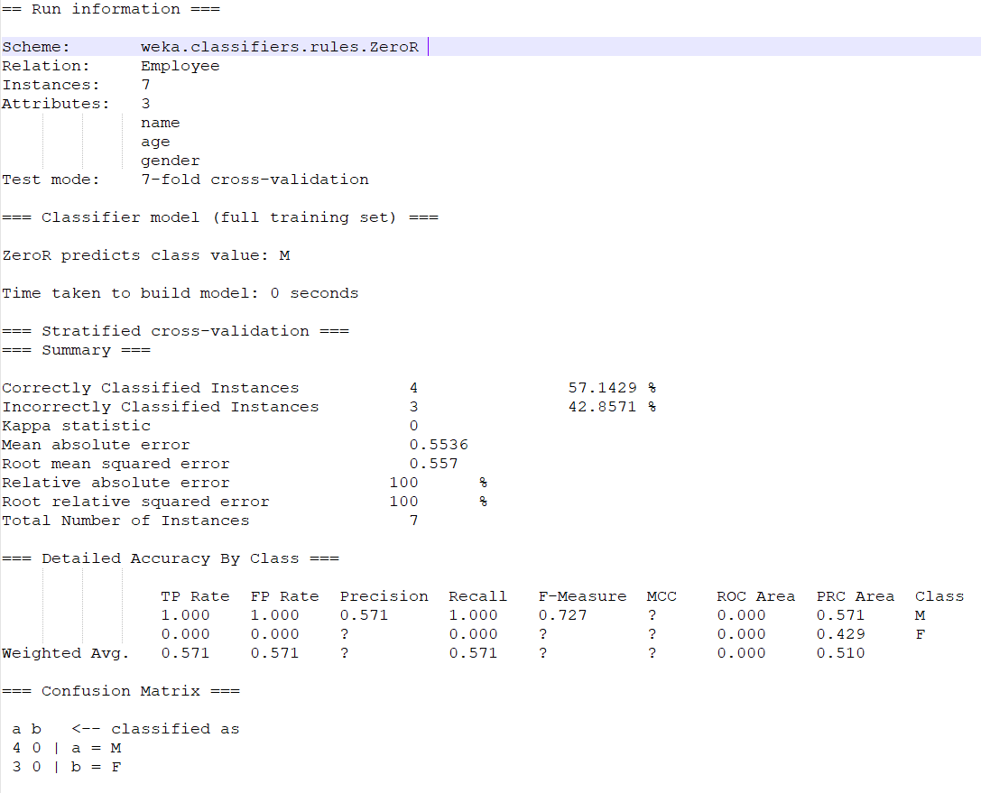

**Clustered Output:**

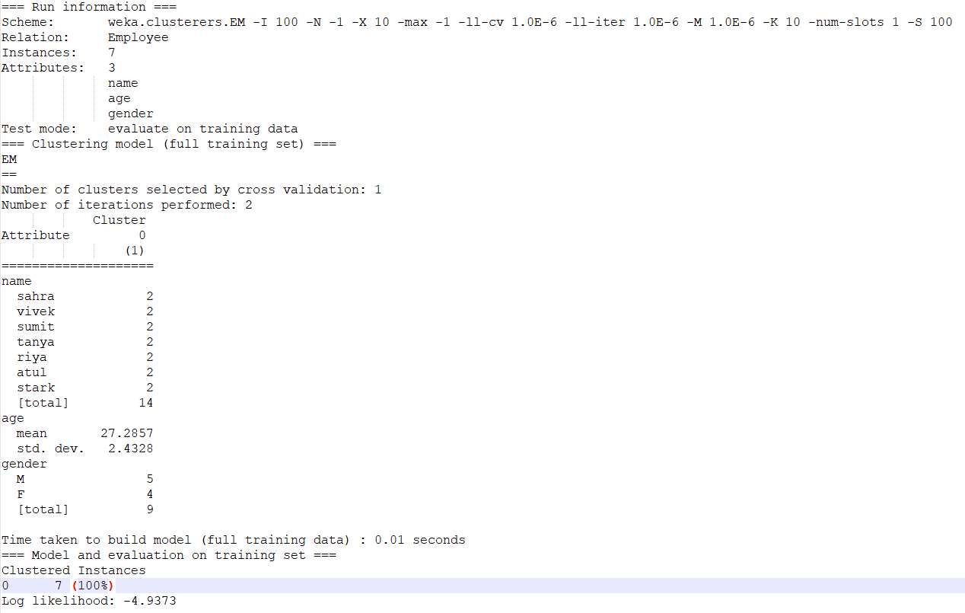

**Visualization:**

